1. Range – 10001, Learning Rate – 0.1, AdagradOptimizer

Training...

step, loss = 0: 0.728

step, loss = 1000: 0.255

step, loss = 2000: 0.256

step, loss = 3000: 0.234

step, loss = 4000: 0.220

step, loss = 5000: 0.213

step, loss = 6000: 0.209

step, loss = 7000: 0.200

step, loss = 8000: 0.191

step, loss = 9000: 0.181

step, loss = 10000: 0.179

loss (test) = 0.17949507

1. Range – 10001, LR – 0.5 (Increased), AdagradOptimizer

**Decrease in Loss – Increase in Learning Rate**

Training...

step, loss = 0: 0.685

step, loss = 1000: 0.212

step, loss = 2000: 0.182

step, loss = 3000: 0.165

step, loss = 4000: 0.154

step, loss = 5000: 0.145

step, loss = 6000: 0.139

step, loss = 7000: 0.124

step, loss = 8000: 0.126

step, loss = 9000: 0.121

step, loss = 10000: 0.114

loss (test) = 0.11416954

Output Image:

1. LR – 0.5, Iteration Range – 12001 (Increased from 10001), AdagradOptimizer

**Decrease in Total Loss**

Training...

step, loss = 0: 0.679

step, loss = 2000: 0.184

step, loss = 4000: 0.149

step, loss = 6000: 0.137

step, loss = 8000: 0.124

step, loss = 10000: 0.116

step, loss = 12000: 0.111

loss (test) = 0.1084143

1. Change in Optimizer – From AdagradOptimizer to GradientDescentOptimizer

LR – 0.5, Iteration Range – 12001

Training...

step, loss = 0: 0.717

step, loss = 2000: 0.233

step, loss = 4000: 0.203

step, loss = 6000: 0.188

step, loss = 8000: 0.166

step, loss = 10000: 0.160

step, loss = 12000: 0.163

loss (test) = 0.15114005

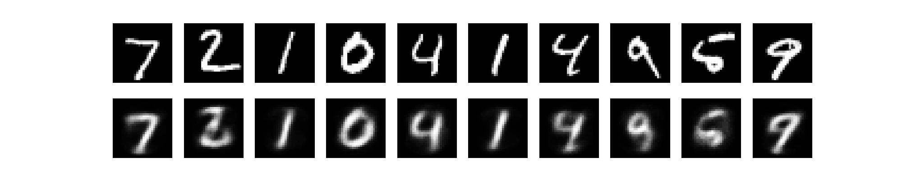

1. RMSPropOptimizer

**LR –** 0.24, Others same as above

Training...

step, loss = 0: 0.736

step, loss = 2000: 0.132

step, loss = 4000: 0.115

step, loss = 6000: 0.126

step, loss = 8000: 0.112

step, loss = 10000: 0.105

step, loss = 12000: 0.114

loss (test) = 0.13345203

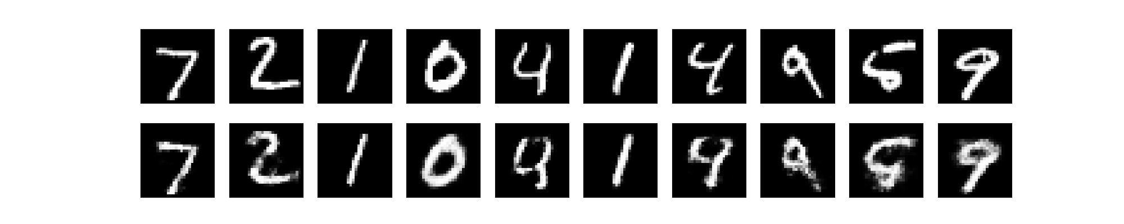

1. AdamOptimizer

LR – 0.001, Others same as above

Training...

step, loss : 0 0.72468084

step, loss : 2000 0.068079695

step, loss : 4000 0.06504184

step, loss : 6000 0.06477794

step, loss : 8000 0.063595444

step, loss : 10000 0.06402872

step, loss : 12000 0.06411824

loss (test) = 0.06373569

